Objective Questions

1. List the different datatypes of columns in the table “ball_by_ball” (using information schema)

Ans: There are a total of 11 columns in the table "ball_by_ball," all of which are of **integer** data type.  
  
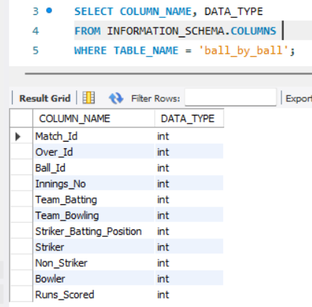

1. What is the total number of runs scored in 1st season by RCB (bonus: also include the extra runs using the extra runs table)

Ans: The total runs scored (including extra runs) in 1st season by RCB is  
**2601**. We obtained this score using the query below.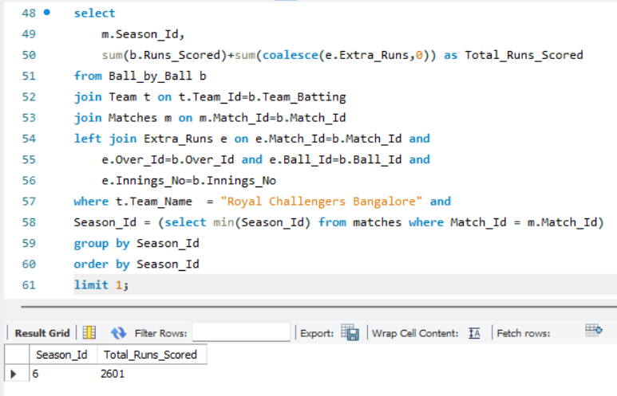

1. How many players were more than the age of 25 during season 2014?

Ans: The number of players who were over 25 years old during the 2014 season is-  
  
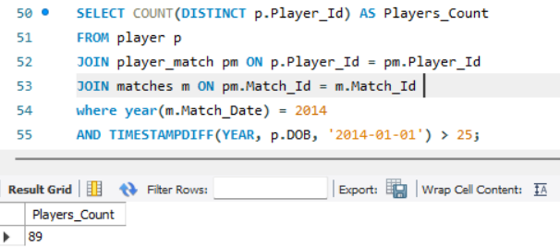

1. How many matches did RCB win in 2013?

Ans: Matches won by RCB in 2013 are-  
  
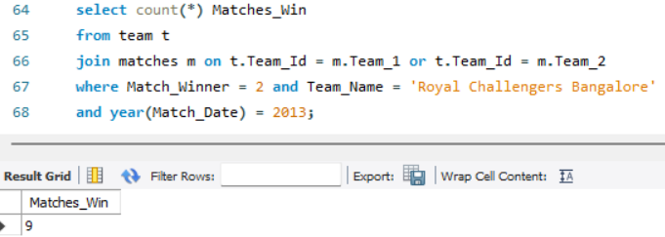

1. List the top 10 players according to their strike rate in the last 4 seasons.

Ans: The top 10 players according to their strike rate in the last 4 seasons are listed below.   
  
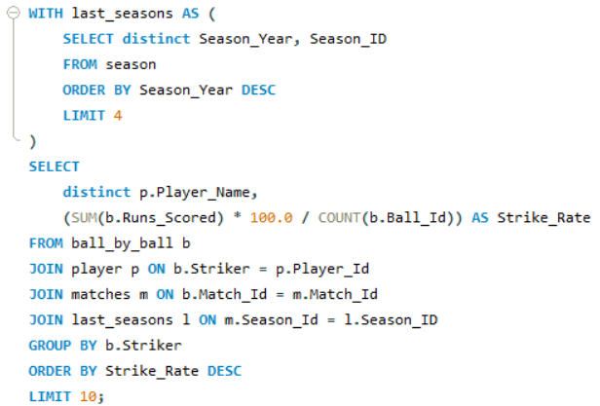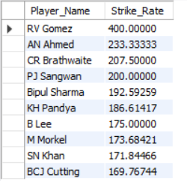

1. What are the average runs scored by each batsman considering all the seasons?

Ans: Here, I’ve calculated the average runs scored by each batsman for all the seasons and attached a few of them.  
  
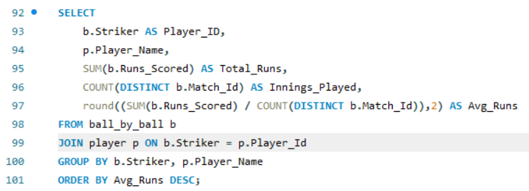  
  
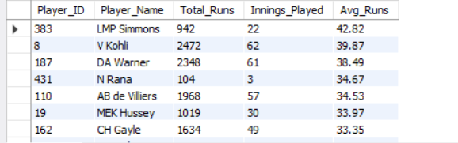

1. What are the average wickets taken by each bowler considering all the seasons?

Ans: Similarly, I’ve calculated the average wickets taken by each bowler for all the seasons and attached a few of them for an example.  
  
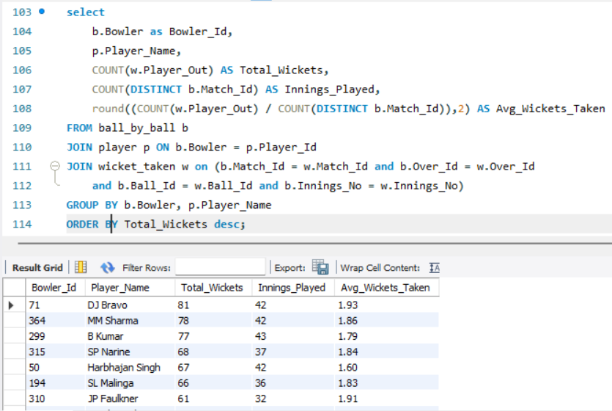

1. List all the players who have average runs scored greater than the overall average and who have taken wickets greater than the overall average.

Ans: To find out players who have scored an average of runs greater than the overall average and who have taken wickets greater than the overall average. I have used the following query-  
  
  
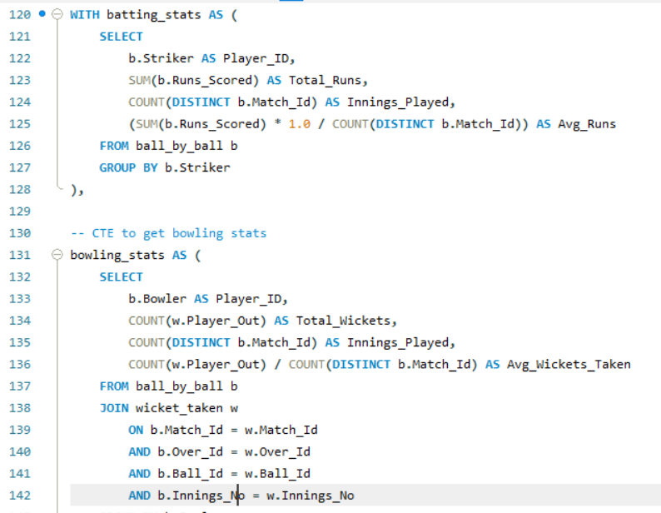  
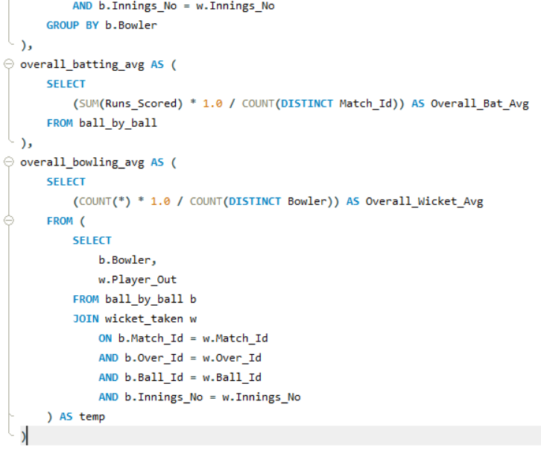  
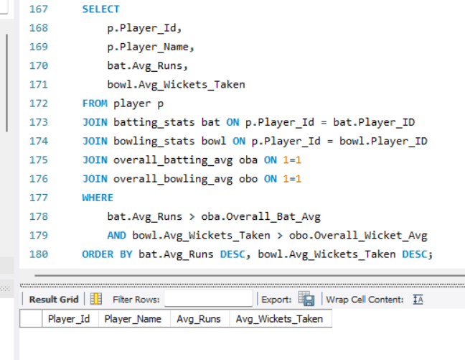

1. Create a table rcb_record table that shows the wins and losses of RCB in an individual venue.

Ans: To obtain the RCB record, which details the wins and losses of RCB at each venue, I used the following query:  
  
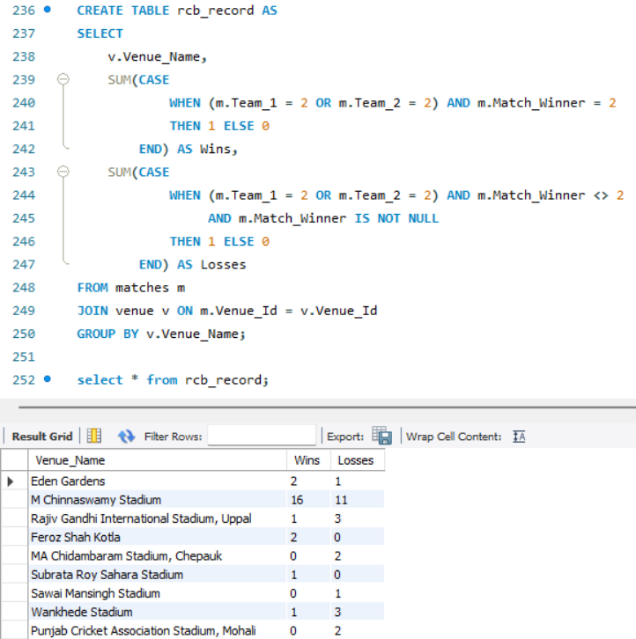  
  
**Note:** Where Team_Id = Team_1 or Team_2. So, Team_Id = 2 (Because that is of RCB)

1. What is the impact of bowling style on wickets taken?

Ans: By analysing the wickets taken by each bowling style, I found that the **Right Arm Medium** style has recorded the highest number of wickets.  
And the query for the same is provided below:  
  
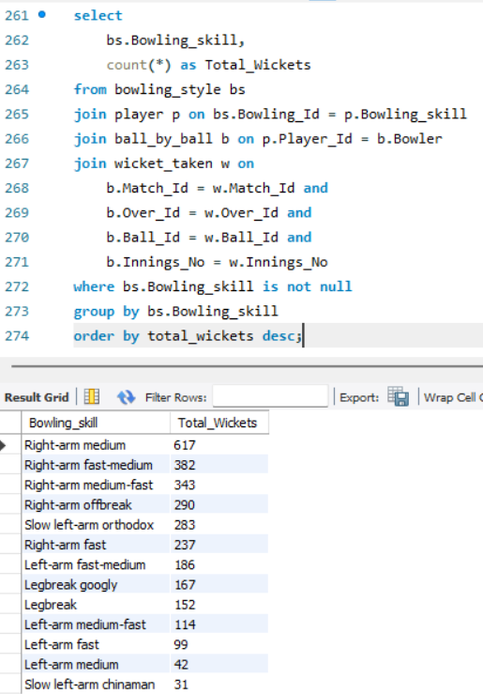

1. Write the SQL query to provide a status of whether the performance of the team is better than the previous year's performance on the basis of the number of runs scored by the team in the season and the number of wickets taken.

Ans: Using the query below, we can achieve the desired result.  
  
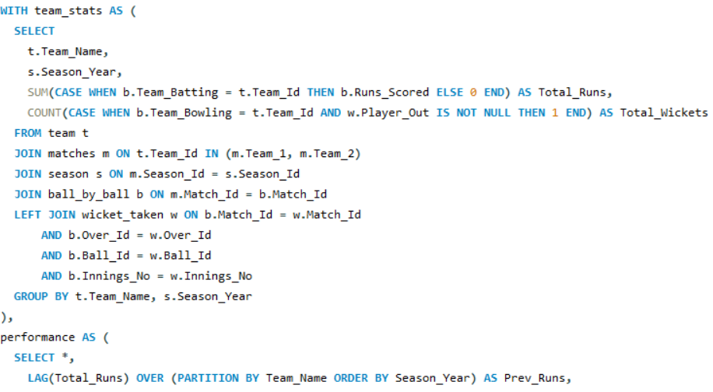

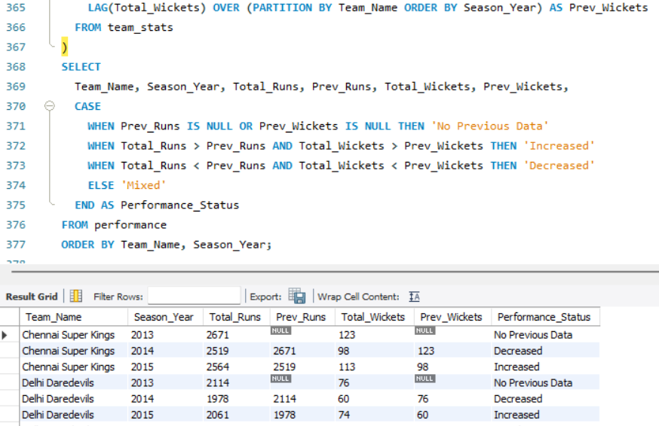

1. Can you derive more KPIs for the team strategy?

Ans: Some advanced key performance indicators (KPIs) for team strategy include:  
  
**1) (a) Dot Ball Percentage (Batting):**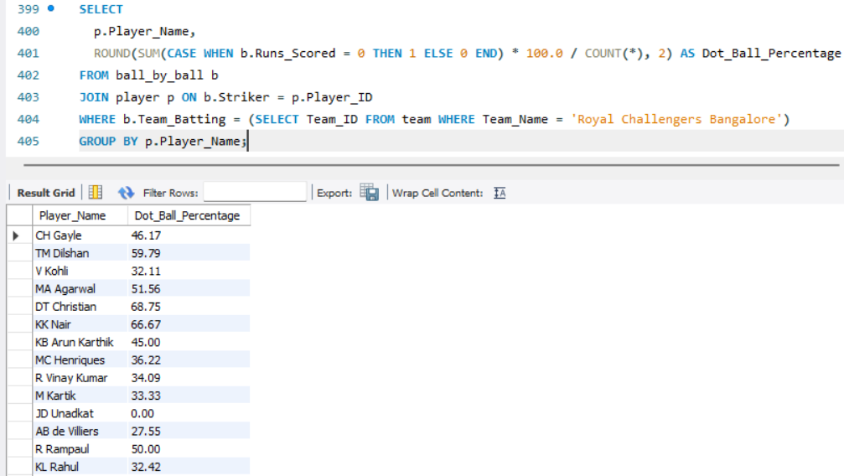

**(b) Dot Ball Percentage (Bowling):  
  
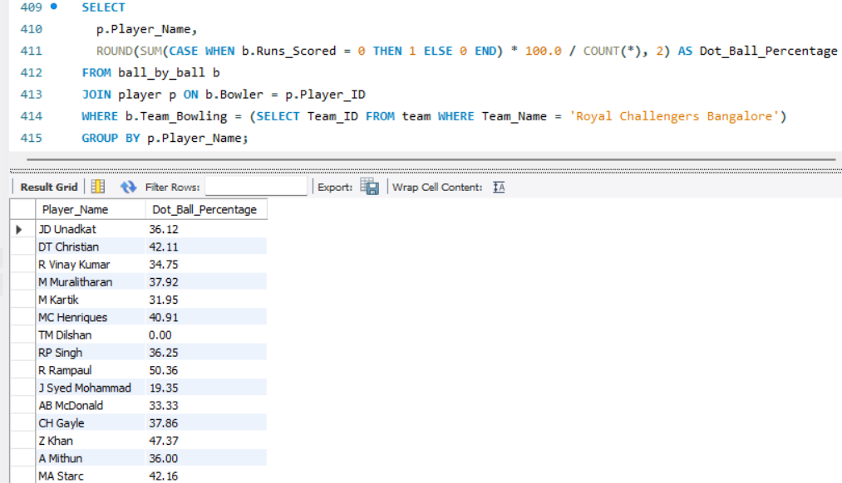**

**2) Boundary Percentage:  
  
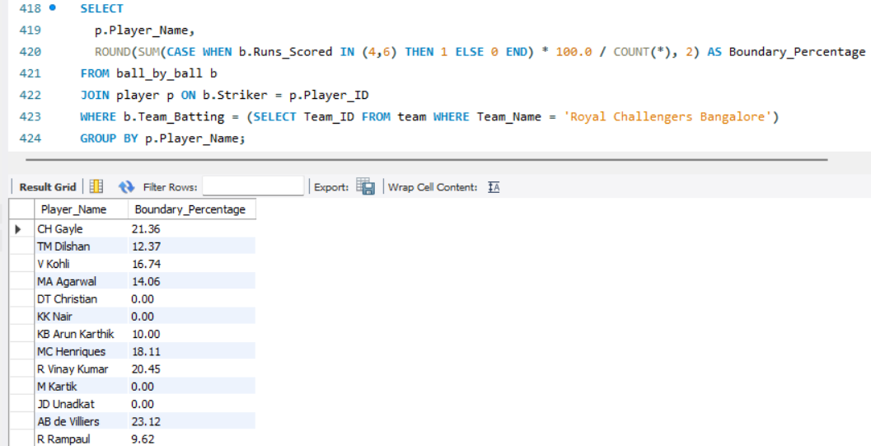**

**3) Phase-Wise Performance:  
  
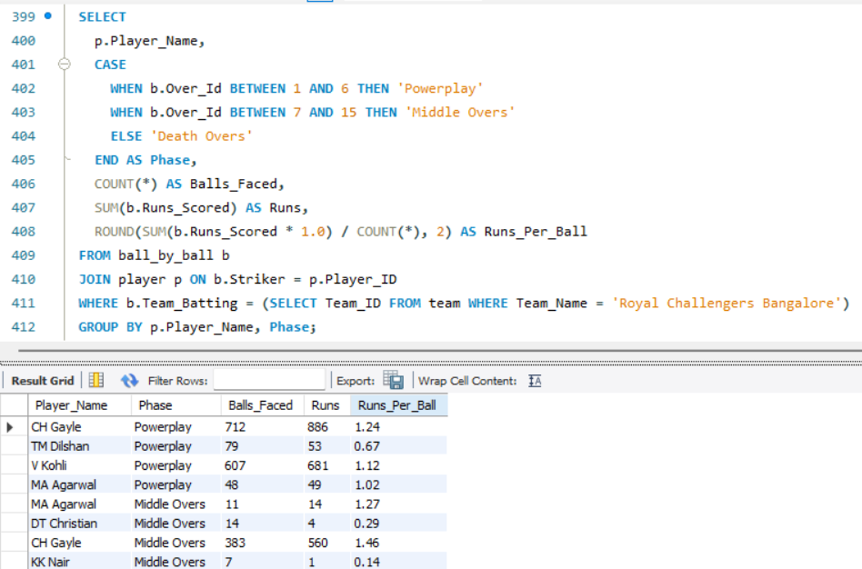**

**4) Bowling Style Effectiveness:  
  
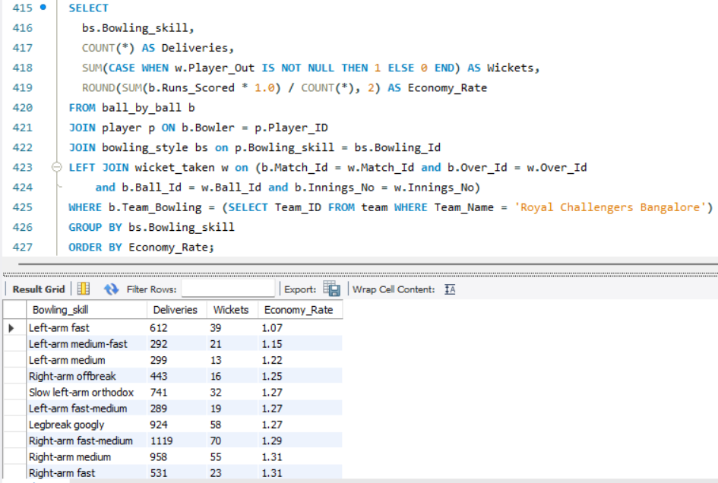  
  
5) Home vs. Away Performance:  
  
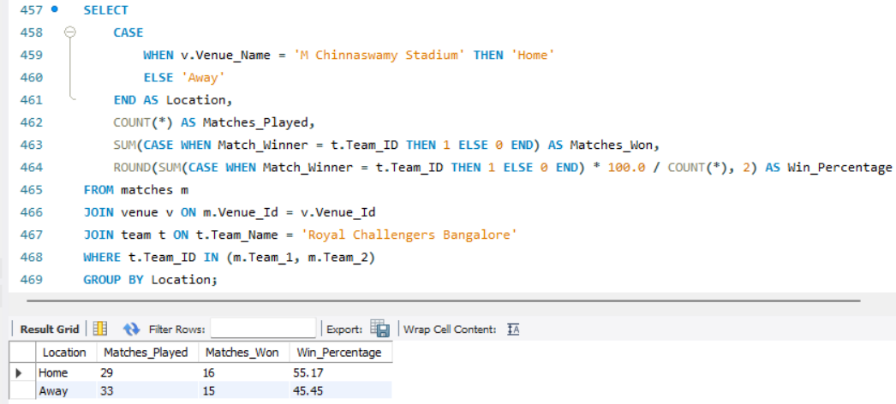**

1. Using SQL, write a query to find out the average wickets taken by each bowler in each venue. Also, rank them according to the average value.

Ans: To get the desired result, we’ve used the following query:  
  
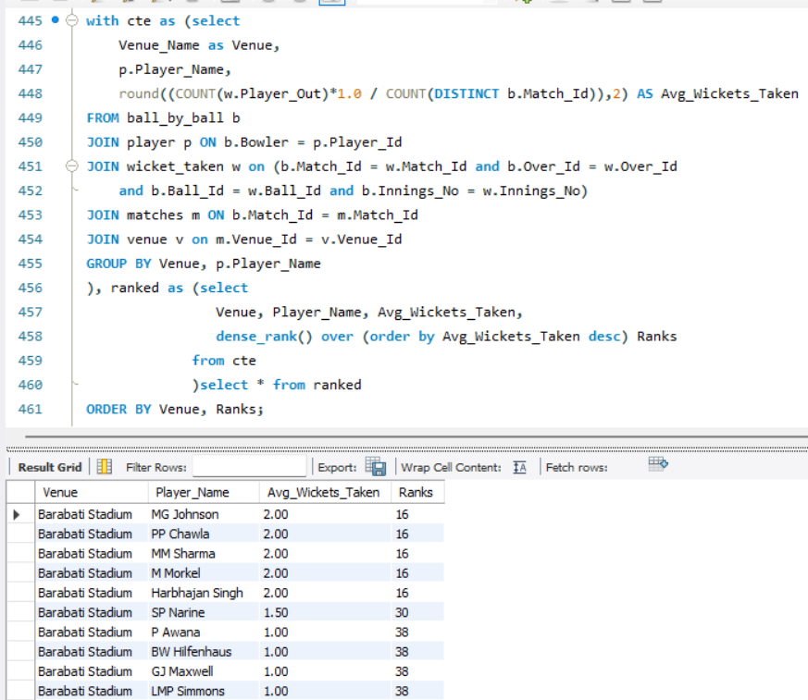

1. Which of the given players have consistently performed well in past seasons? (Will you use any visualization to solve the problem?)

Ans: **Aim-**   
1. To identify the most **consistent and high-scoring batsmen.**  
2. Who has played many innings and maintained a good average?  
3. A good input for **team building, retention, or auction planning**.

**Query-**  
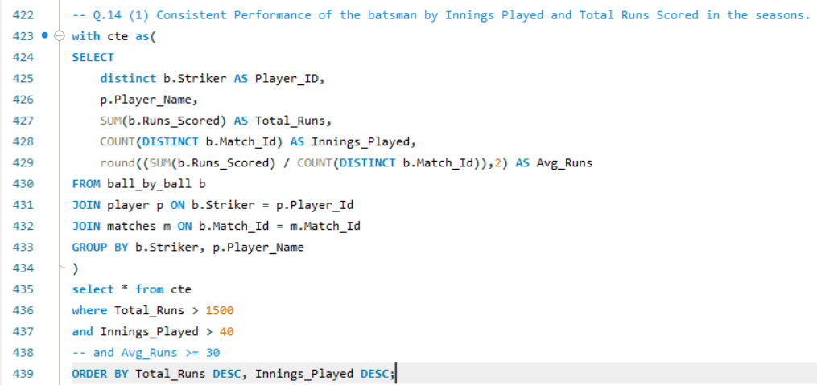  
  
**Visuals-**  
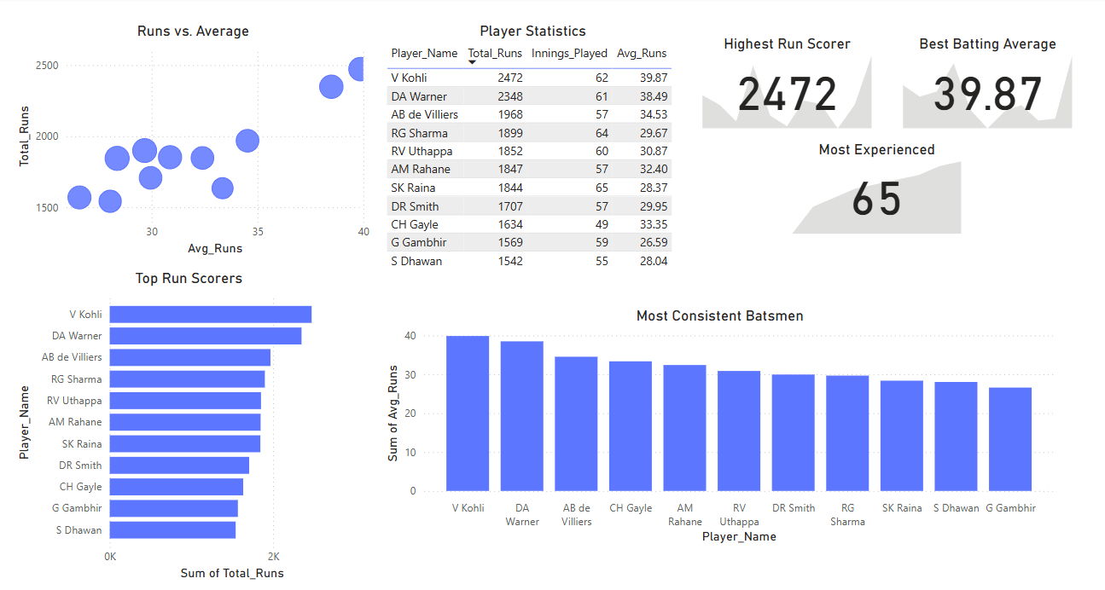  
 **Aim-**Identifying the consistent and impactful bowlers by analysing total wickets and average wickets per match. We'll focus on those with over 30 innings and more than 55 wickets, using historical data. This analysis will help evaluate bowling strength and guide our retention or release strategy before the auctions.

**Query-**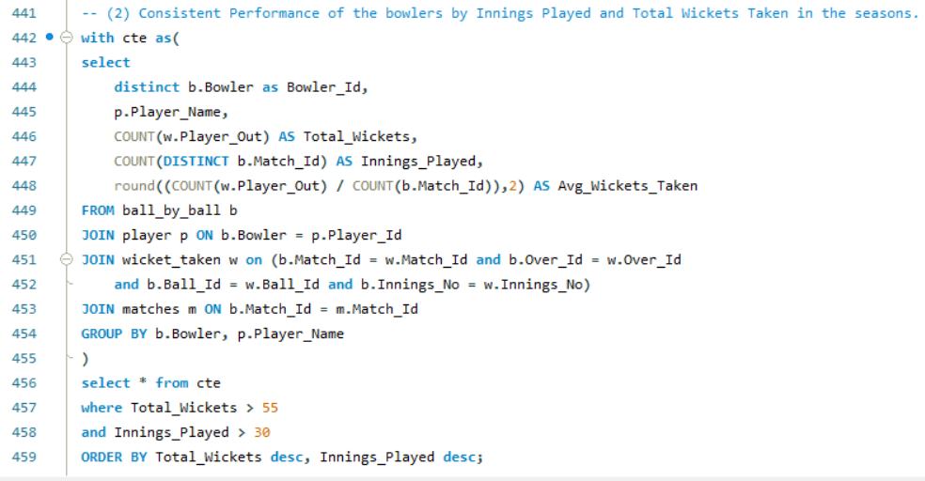  
  
**Visuals-  
  
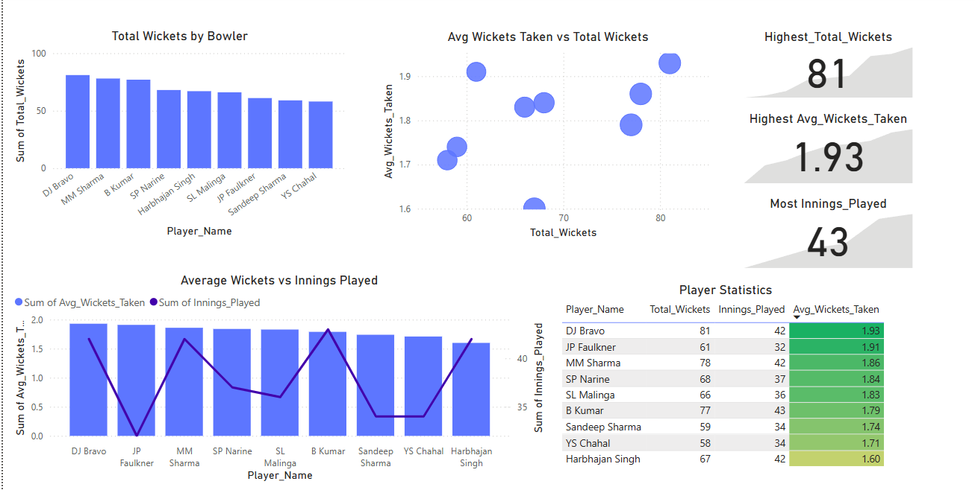**  
**Key Insights-  
  
Batting Performance**   
  
**1. Virat Kohli**, **David Warner**, and **AB de Villiers** are the top performers in terms of **total runs** and **batting average**.  
2. **Kohli** stands out as the **highest run scorer** and most **consistent batsman**.  
3. Teams with these players had strong top-order batting.

### **Bowling Performance**

* **DJ Bravo**, **MM Sharma**, and **B Kumar** are the **top wicket-takers**.
* **Bravo** also has the **highest average wickets per match**, showing consistency.
* The most experienced bowler (by innings) is **B Kumar**.

**Observation**

* **Teams with balanced contributions** across both batting and bowling had better outcomes.
* **RCB** (implied focus) had a strong batting core but **lacked consistent high-performing bowlers**, which could explain performance issues.
* **Over-reliance on key players** without a balanced squad might have led to underperformance in crucial matches.

1. Are there players whose performance is more suited to specific venues or conditions? (How would you present this using charts?)

Ans:   
**Aim-** To analyse **batsmen's performance variation across different venues** by comparing their **average runs at each venue** versus their **overall average runs**. This helps identify players who significantly outperform or underperform at certain stadiums.  
 **Visuals-**  
 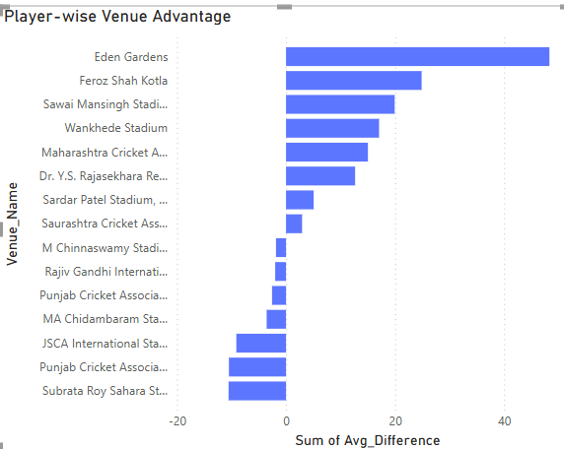

**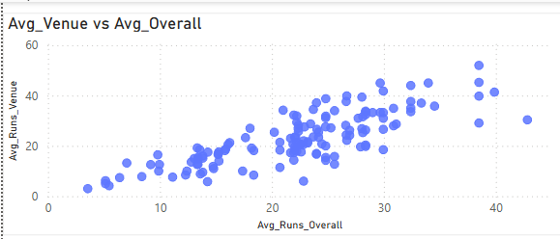  
  
Query-**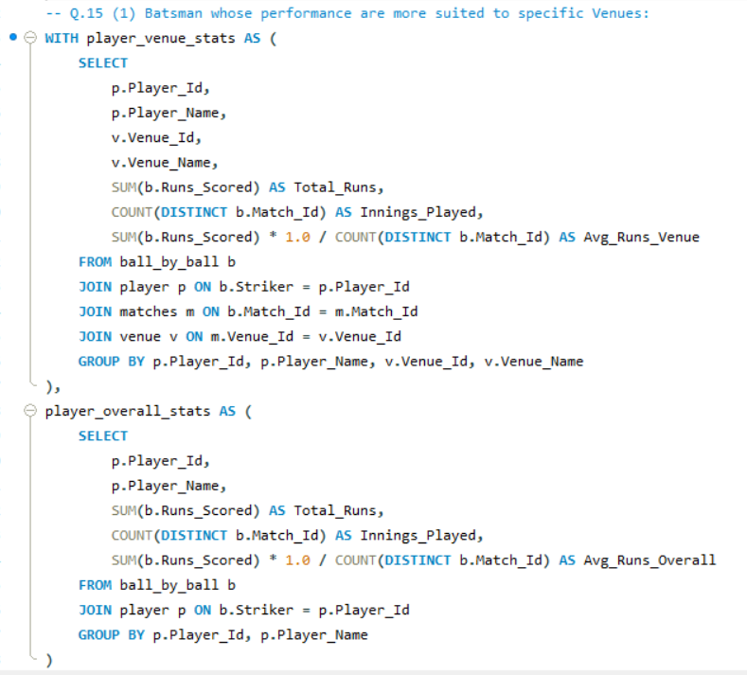  
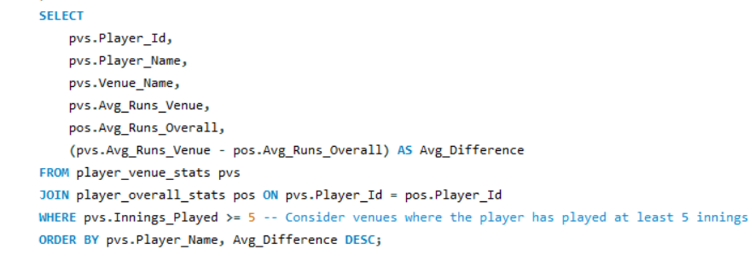 **Aim-**To **analyse bowler performance across different venues** and identify:

* Venues where bowlers perform **significantly better** than their overall average (*Top Venue Boost*).
* Venues where bowlers perform **significantly worse** than usual (*Worst Venue Dip*).
* Which players have the **most variable performances** based on venue?

**Visuals-   
  
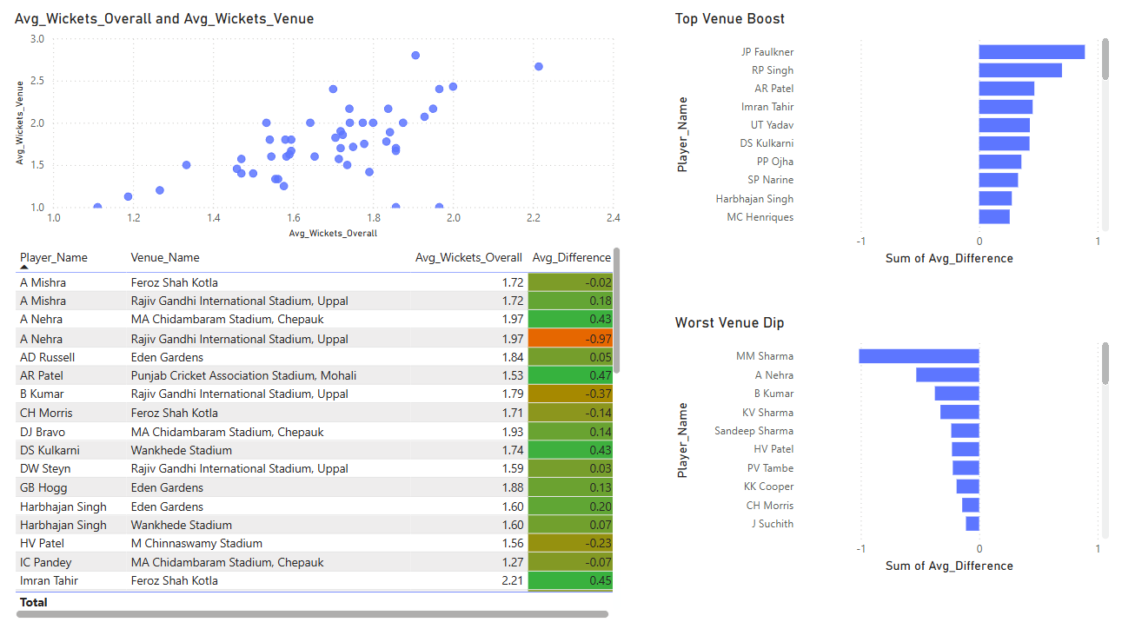**

**Query-**  
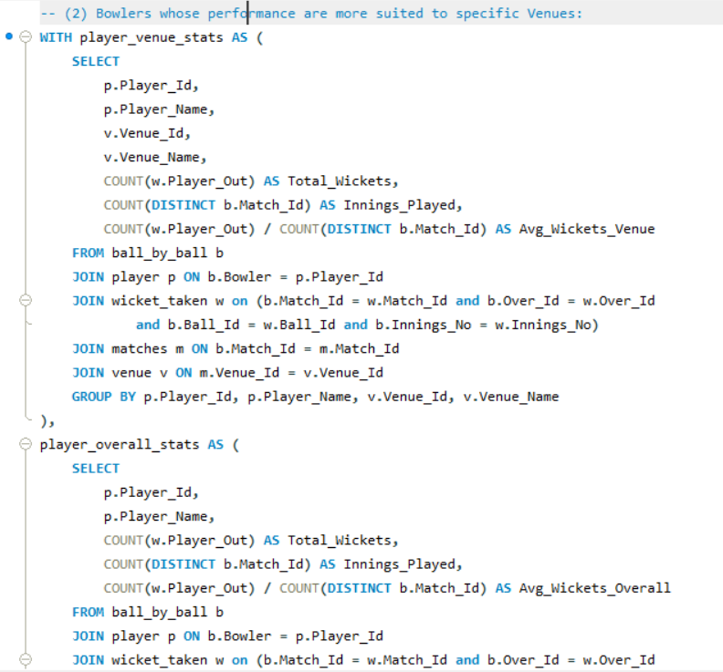  
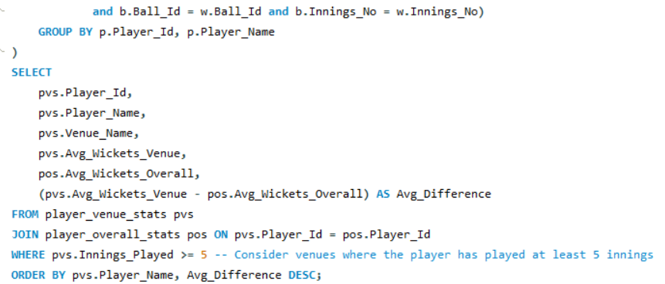

**Conclusion-**

**Batting Insights:  
1. Top Venue Boosts (Best Performers at Specific Venues):** a. DA Warner at Rajiv Gandhi Stadium (Hyderabad) showed the highest positive average difference, meaning he performs significantly better at this venue compared to his overall average.

b. V Kohli at M Chinnaswamy Stadium (Bangalore) also showed a notable performance boost, indicating home ground advantage.  
  
**2. Venue Dips (Underperforming Grounds):**

a.SK Raina at Eden Gardens (Kolkata) had one of the most significant dips in average performance compared to his overall batting average.

b. DR Smith and S Dhawan also showed declines at some venues despite overall good performances.

**Bowling Insights:  
  
1. Top Venue Boosts (Best Bowling Grounds):**a.YS Chahal at M Chinnaswamy Stadium had the highest positive average wickets difference, indicating this is a favourable venue for his bowling style.

b. SL Malinga at Wankhede (Mumbai) also excelled beyond his overall average here.

**2. Worst Venue Dips (Challenging for Bowlers):**

a. B Kumar and Harbhajan Singh at Rajiv Gandhi Stadium underperformed significantly relative to their usual wicket-taking averages.

b. Some bowlers like S Narine had consistent dips at particular venues, suggesting those grounds may not suit their style.

**Recommendations-**1. **Home Advantage is Real:** Players often outperform at their home grounds (e.g., Warner in Hyderabad, Kohli in Bangalore, Chahal in Bangalore).

2. **Venue Suitability Matters:** Certain venues favour specific player types — flat tracks favour batsmen while spinner-friendly or seam-friendly tracks favour bowlers.

3. **Strategic Team Planning:** Understanding venue-based performance helps in match strategy, fantasy picks, and team selection.

Subjective Questions

1. How does the toss decision affect the result of the match? (Which visualisations could be used to present your answer better?) And is the impact limited to only specific venues?

Ans:   
**Approach-** To determine whether the **toss decision** (bat or field) has a significant effect on **match outcomes**, and whether this effect is **venue-dependent**.  
  
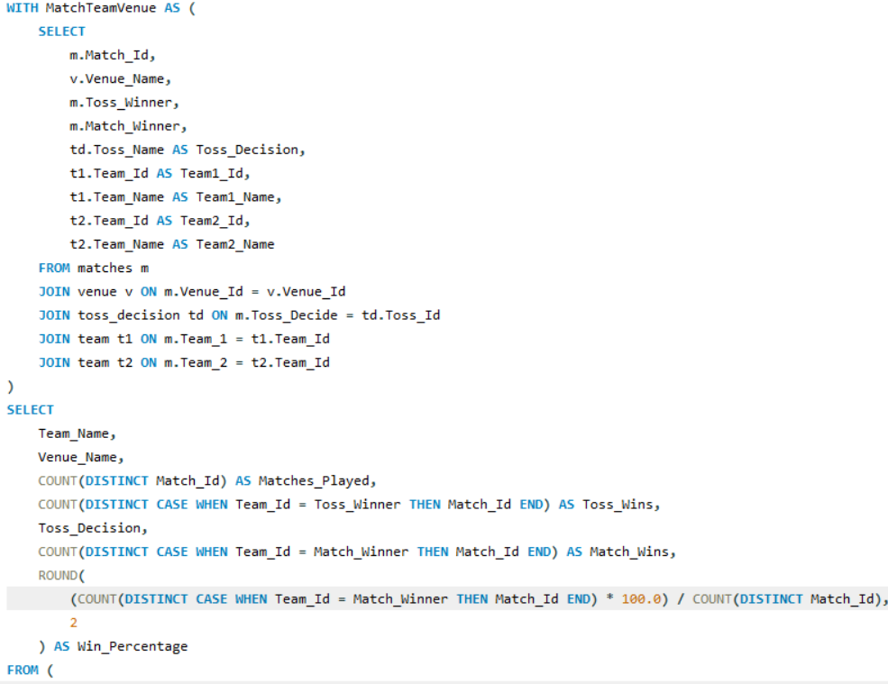  
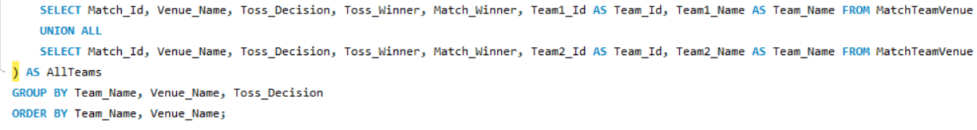  
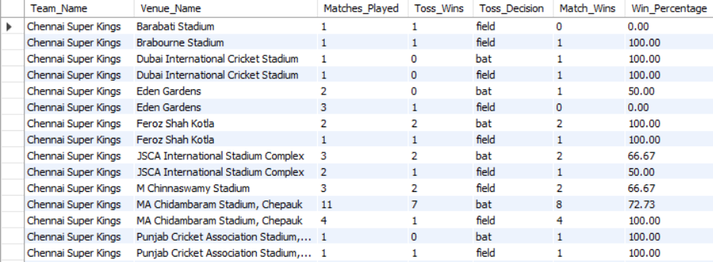  
  
**Visuals-**  
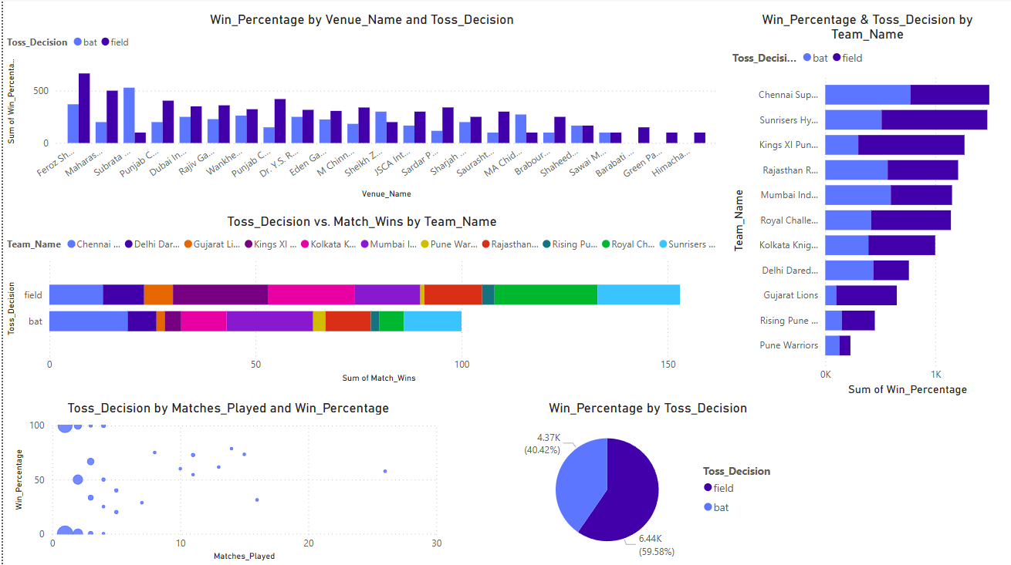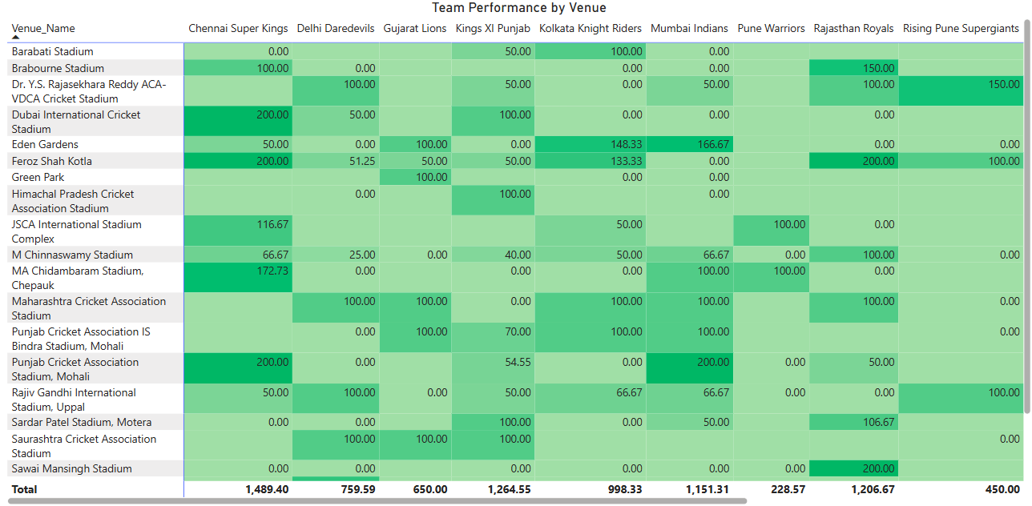**Insights-**

**1. Batting First Often Wins**

* + Teams win more often when they choose to bat first after winning the toss (about 60% of the time).
  + Fielding first leads to fewer wins overall.

1. **Some Venues Favour Batting First**
   * Grounds like Feroz Shah Kotla, Eden Gardens, and Chepauk (MA Chidambaram) show better win results when teams bat first.
   * In some venues, it doesn't matter much – both decisions perform equally.
2. **Strong & Weak Team Performances**
   * Chennai Super Kings, Mumbai Indians, and Rajasthan Royals perform well across multiple venues.
   * Teams like Pune Warriors, Delhi Daredevils, and Gujarat Lions have struggled at many grounds.
3. **Toss Doesn’t Guarantee Wins**
   * Winning the toss helps, but how a team plays matters more.
   * Some teams win more even when they lose the toss – they adapt better.

**Recommendations-** 1. Choose to bat first in most venues, especially where batting has worked well in the past.

2. Know your strong venues — play with more confidence and plan strategies accordingly.  
 3. Use toss results to plan, but don’t rely on them fully — performance on the field still wins matches.  
 4. Teams should look at past venue results to make smarter decisions on toss and team selection.

1. Suggest some of the players who would be the best fit for the team.

Ans: **Approach-** To find the best players for the team, I’ve categorised them into 3 categories, such as  
  
**(1) Top Batsmen:**  
  
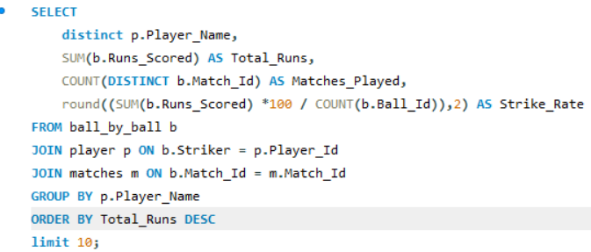  
  
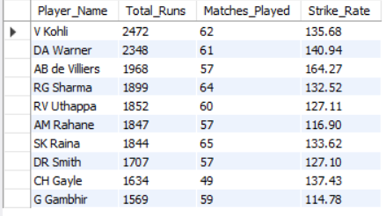

**Insights for Batsmen-**1. The top batsmen are consistent performers with high total runs.

2. Some players score very quickly (high strike rate), making them valuable in T20s.

3. A few players have made a big impact in fewer matches — they show great potential.  
4. Openers usually score more runs, while middle-order players often have higher strike rates.

**(2) Top Bowlers:**  
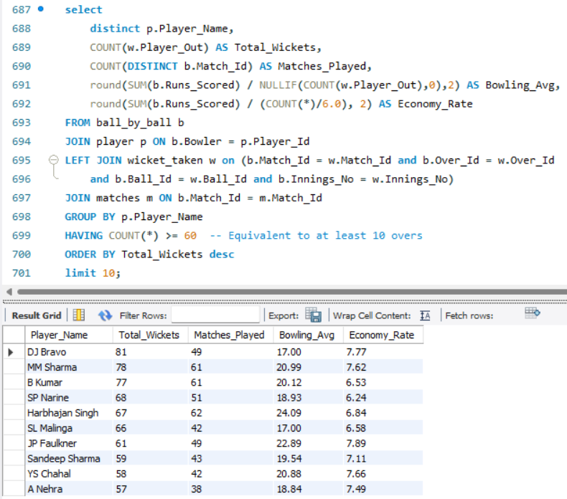  
  
**Insights for Bowlers-**1. These bowlers take the most wickets and play a key role in winning matches.

2. Some are very economical, giving away few runs — great for controlling the game.

3. Bowlers with low averages are efficient, taking wickets while conceding fewer runs.

**(3) Top All-Rounders:**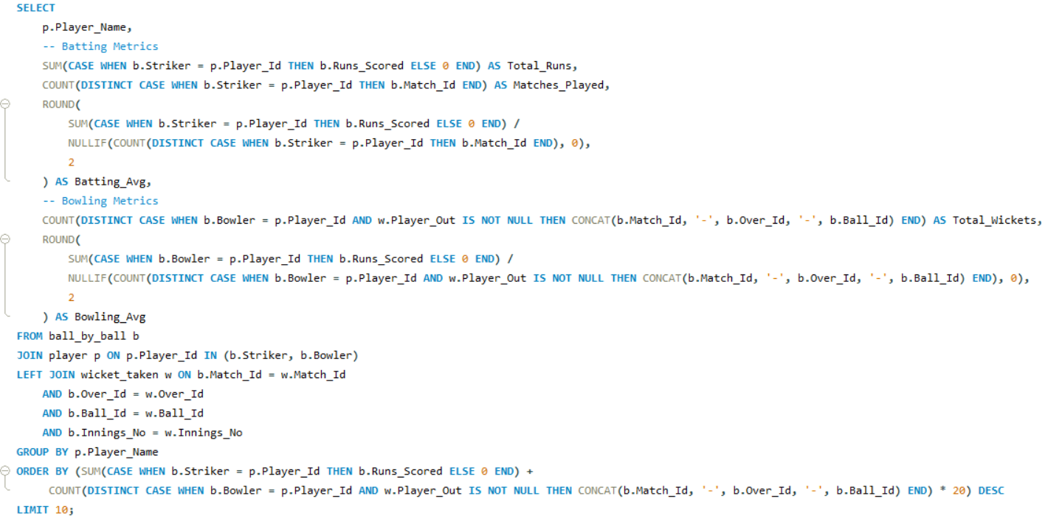

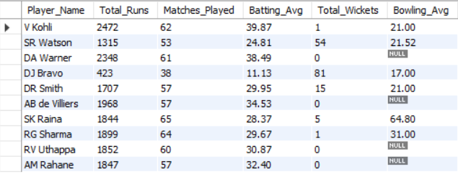 **Insights for All-Rounders-**1. These players contribute both with the **bat and ball**, making them extremely valuable to the team.

2. Some players score big runs and also take many wickets — true match-winners.

3. All-rounders with a **good batting average and low bowling average** offer balance and flexibility to the team.

**Recommendations-**1. **Batsmen:** Keep players who score runs regularly. Use fast scorers at the start or end of the innings. Choose players based on the match type (T20, ODI, etc.).

2. **Bowlers:** Keep those who take a lot of wickets. Use bowlers who give fewer runs in the middle overs. Pick bowlers based on pitch and match conditions.

3. **All-Rounders:** Focus on players who are good at both batting and bowling. They give the team balance and more options.

1. What are some of the parameters that should be focused on while selecting the players?

Ans: **Approach-** By analysing key performance metrics, we can conclude the following points:

**Top Performers by Discipline**

* **Batsmen**: Players with high total runs and batting averages indicate consistent scoring ability.​
* **Bowlers**: Those with a high wicket tally, low bowling average, and favourable economy rate demonstrate effective bowling performance.​
* **All-Rounders**: Players who contribute significantly in both batting and bowling, as reflected by combined metrics such as the All-Rounder Score, offer valuable versatility.​

**Insights-**  
**1.** **Batsmen Performance-  
  
  
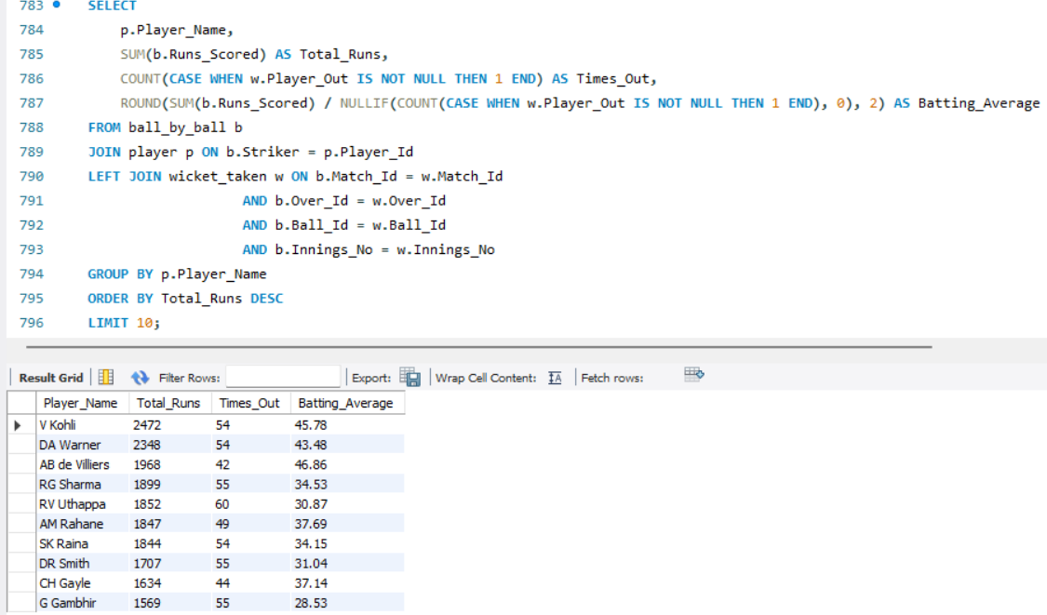**

**2. Bowler Performance-**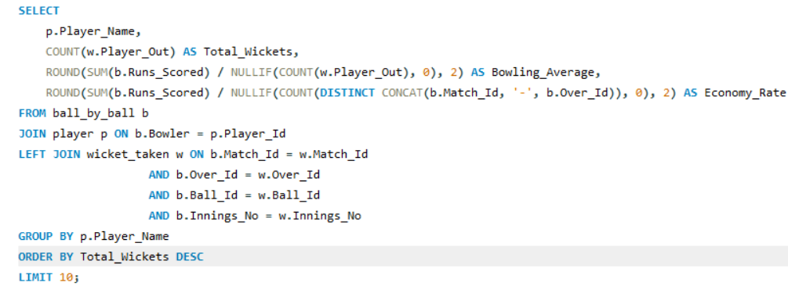  
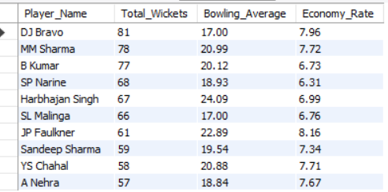 **3. All-Rounder Performance-  
  
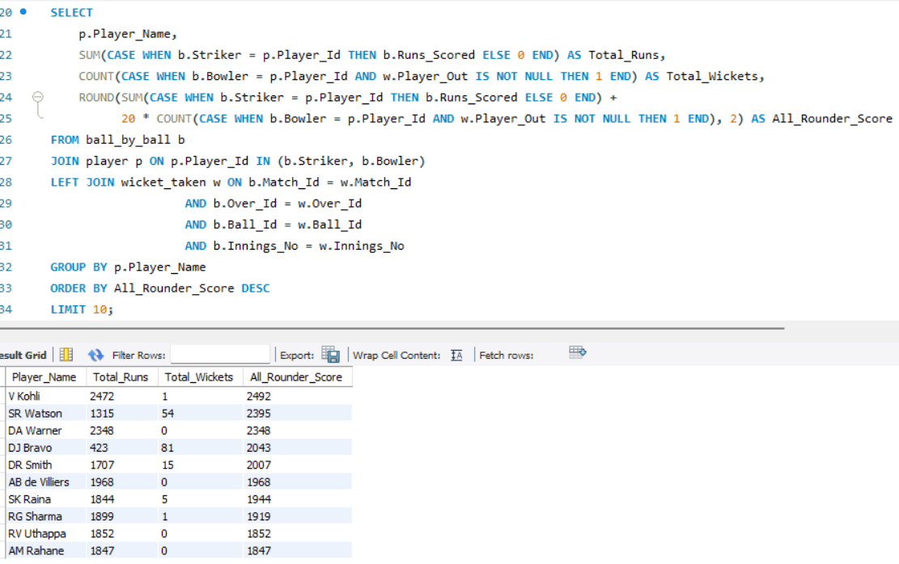**

**Recommendation-** Justifying Player Selection

By analysing the following metrics:​

* **Consistency**: High batting averages and low bowling averages indicate reliable performance.​
* **Impact**: Total runs and wickets reflect the player's overall contribution to matches.​
* **Efficiency**: Economy rates and strike rates show how effectively a player performs their role.​

These insights allow selectors to make informed decisions, ensuring a balanced and competitive team composition.

1. Which players offer versatility in their skills and can contribute effectively with both bat and ball? (Can you visualize the data for the same?)

Ans: **Approach-** Here, I’m selecting players who have scored over 500 runs and taken at least 20 wickets — a suitable threshold to define impactful all-rounders.  
  
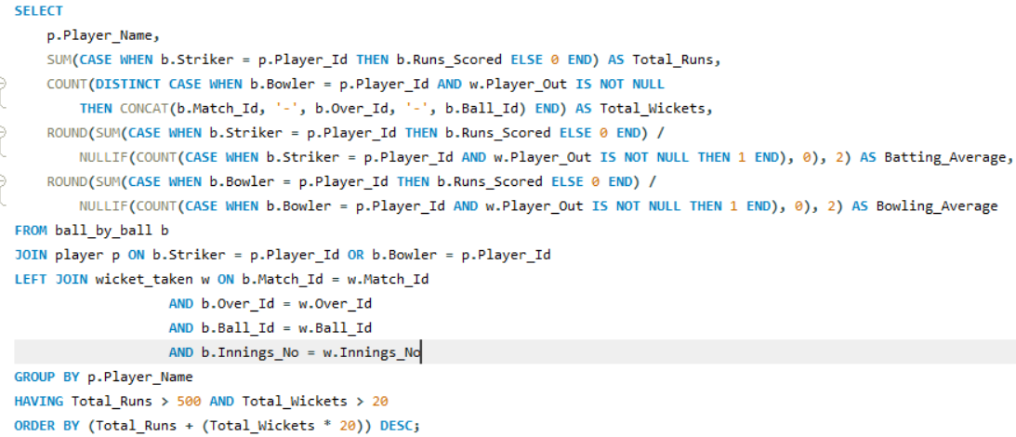  
  
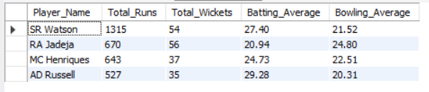  
  
**Insights-**1. The resulting players are **versatile all-rounders** — they score runs and take wickets regularly.

2. Players with a **high batting average and low bowling average** are the most efficient.

3. The combined score helps identify the **most valuable all-rounders**, not just those who are good at one discipline.

4. Some players may have fewer wickets but higher batting output, and vice versa — helpful for **role-based selection**.

**Visuals-  
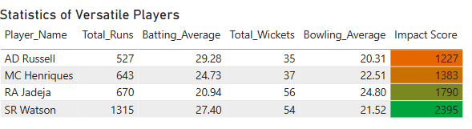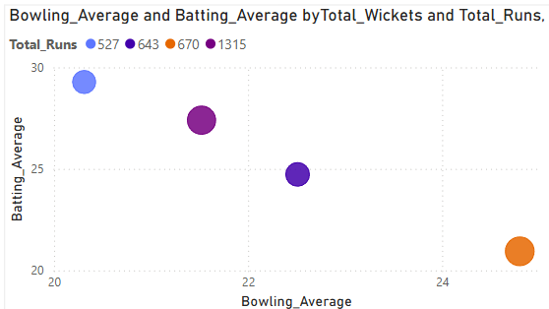**  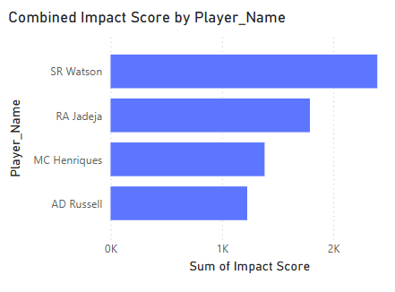

**Recommendations-** 1. Pick all-rounders who bat well and bowl economically — they’re the most valuable.  
 2. Use them in the middle order and as backup bowlers to give your team balance.

3. Choose players with high runs and wickets — they make big impacts.

4. Adjust their roles based on pitch and opponent (batting vs bowling-friendly).

5. Rotate them smartly to avoid burnout and keep performance high.

1. Are there players whose presence positively influences the morale and performance of the team? (Justify your answer using visualization.)

Ans: **Approach-** To understand and fetch the players who positively influence the morale and performance of the team  
 **(1) Choose a Player-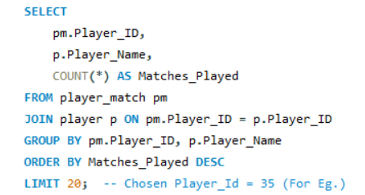  
  
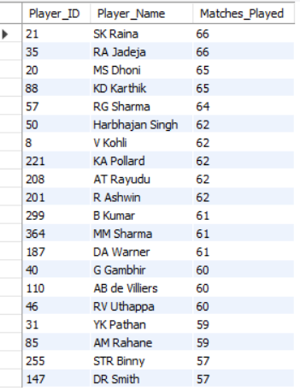  
  
(2) Team Win Rate When the Player Played vs When the Player Did Not Play-**  
Here, for the experiment, I’ve examined the team’s winning ratio based on a single player.  
 **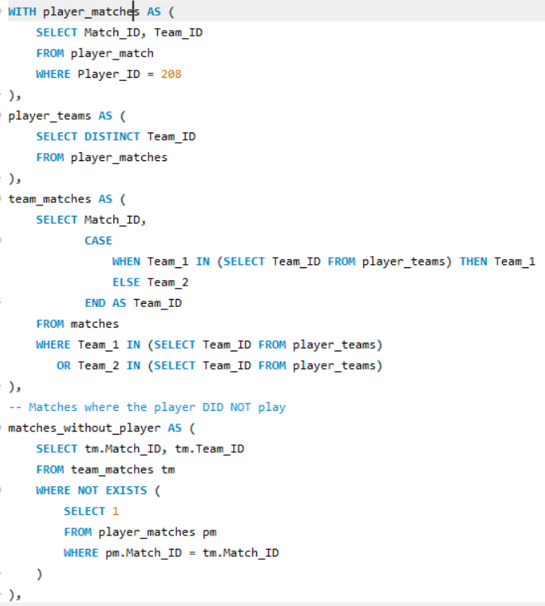  
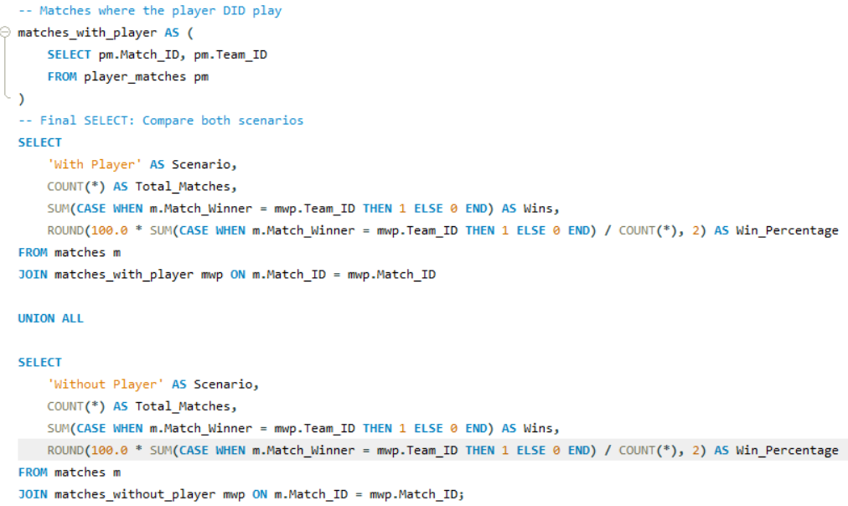  
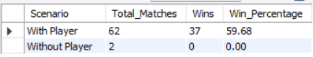**

**Insights-**

1. If the win percentage is higher when the player is present, it clearly shows their positive influence, be it through experience, leadership, or skill.

2. These are likely core players whose presence boosts confidence, strategy execution, and team performance.  
  
**Visuals-** The best way to interpret this is using column and pie charts.  
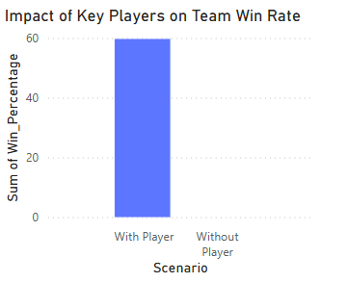  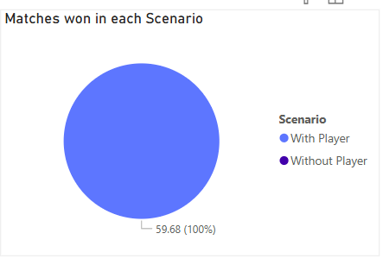

**Conclusions-**

1. Yes, some players boost team performance.  
2. Their presence leads to a higher win rate, proving their value beyond just personal stats.  
3. These players likely bring experience, leadership, or psychological advantage.

**Recommendations-**1. Retain and build teams around such players, especially for high-pressure matches.

2. Use them as mentors for younger players.

3. Avoid resting them in crucial matches unless necessary — their impact is measurable.

4. Track their presence in future match analysis to monitor ongoing influence.

1. What would you suggest to RCB before going to the mega auction?

Ans: **Approach-   
  
1. Find out which players have the highest match impact for RCB**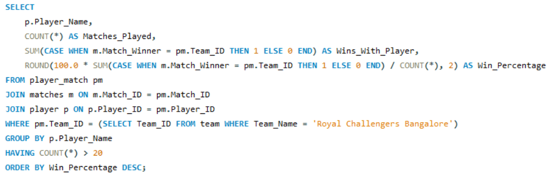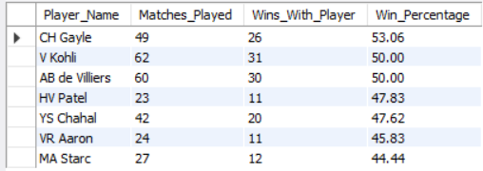  
 **2. Death Over Bowling Problems? Check the Economy in Overs 16 to 20**

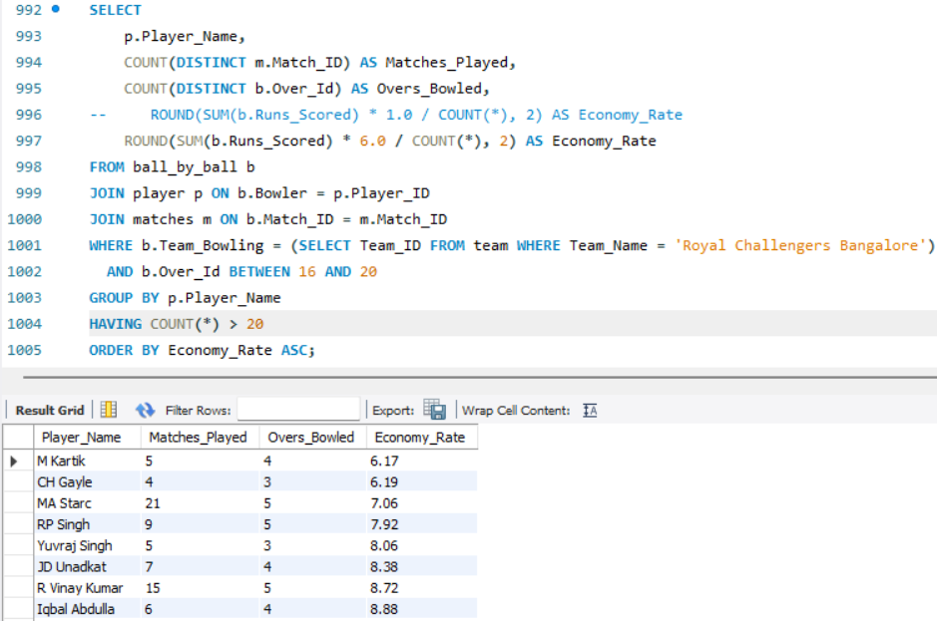  
  
Here, I’ve listed the top few bowlers only.  
  
**3. RCB Batting Collapses? Find Out by Over Segment  
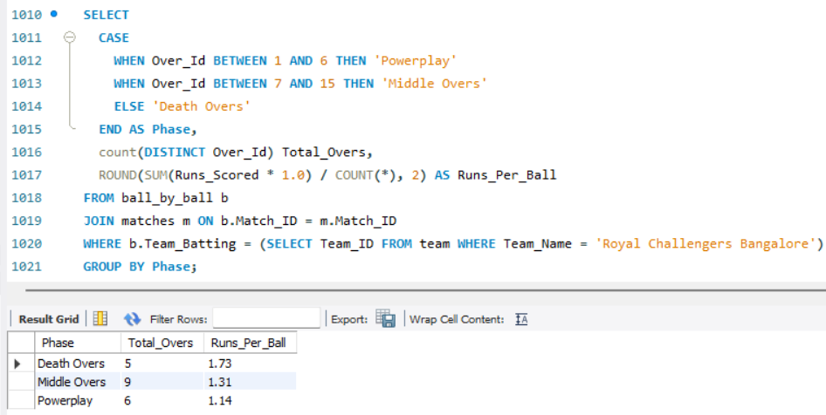**

**4. Which Players Perform Best Against RCB?  
  
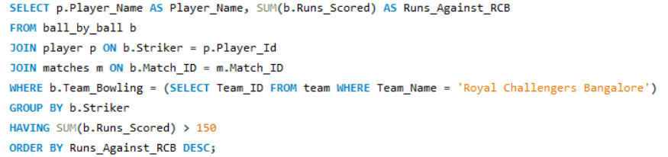**   
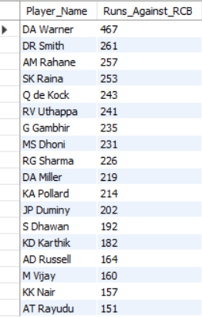  
 **Insights-  
  
1. Match Winners Identified**

* Players like Chris Gayle, Virat Kohli, and AB de Villiers have over a 50%-win rate when in the team. These are high-impact players.

**2. Death Over Struggles**

* RCB’s bowlers like RP Singh and Starc have high economy rates in overs 16–20, showing vulnerability in closing matches.

**3. Top Opponent Threats**

* Players like David Warner, Rahane, and Raina have consistently scored big against RCB and can turn matches one-sided.

**Recommendations-**1. **Keep high-impact players –** Retain match-winners like Gayle, Kohli, and ABD, or find similar consistent performers.

2. **Fix death over bowling –** Target bowlers who are economical and reliable in overs 16–20.

3. **Plan for tough opponents –** Have clear strategies against players like Warner, Dhoni, and Rohit, who often score big vs RCB.

4. **Strengthen middle order –** Add stable batsmen and finishers to avoid batting collapses.

1. What do you think could be the factors contributing to the high-scoring matches and the impact on viewership and team strategies?

Ans: Factors that contribute-  
  
**1. High-scoring matches:**  
 a. Flat pitch: Advantage for Batsmen.

b. Short boundaries: Carry good chances of higher runs.

c. Home ground: Advantage for the team as they get a big support system from their audience and familiar conditions, like the pitch performance, whether it is a slow/fast pitch.  
 d. Good partnership among Batsmen.  
  
 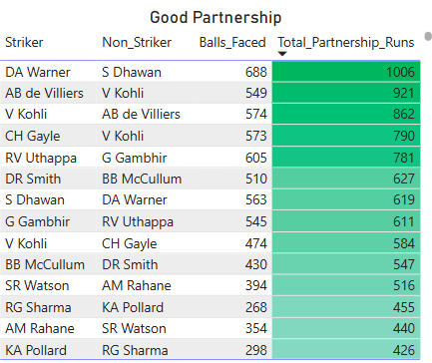

**2. The impact on viewership:**

a. Matches between Rivalries.

b. Close competition or death over.

c. Chasing team performance.

d. Fan favourites team

e. Playoff matches hold a large viewership.  
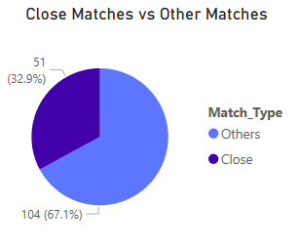 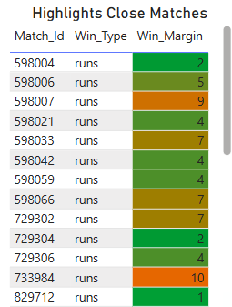  
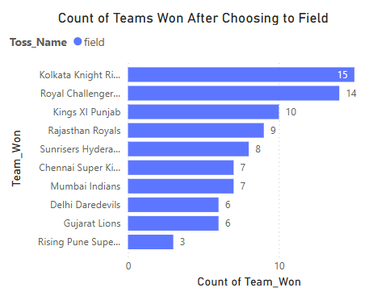 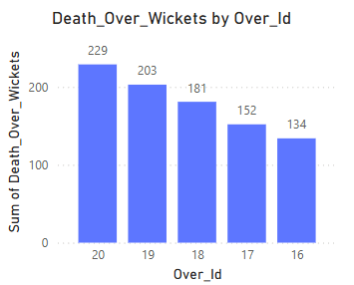  
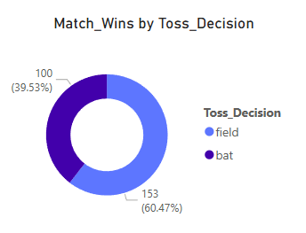

**3. Team strategies:**

a. Strong Batting Lineup.

b. Great fast and spin bowlers.

c. Good all-rounders.  
 d. Playing 11 according to the pitch.

e. The player who performs best against the team should be targeted well.  
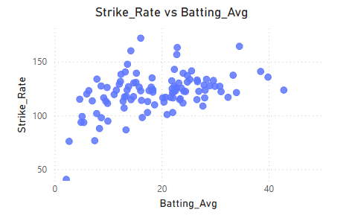 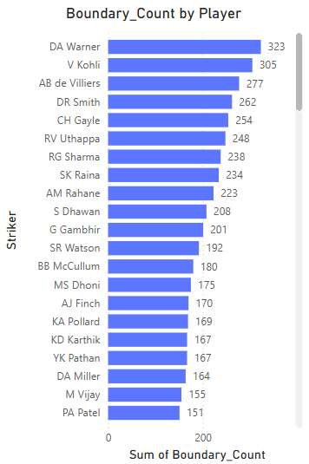  
  
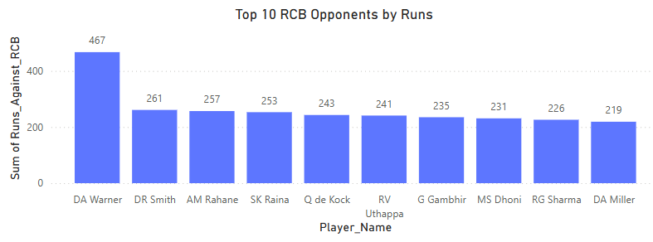

1. Analyse the impact of home-ground advantage on team performance and identify strategies to maximize this advantage for RCB.

Ans: **Approach-** To evaluate how Royal Challengers Bangalore (RCB) performs at home (M Chinnaswamy Stadium) vs. away venues, and identify strategies to make the most of their home advantage.  
  
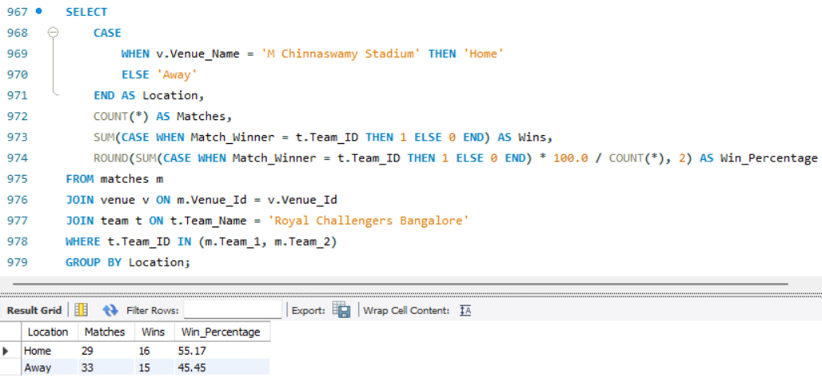  
  
**Insights-**1. RCB has a **higher win percentage at home** compared to away matches, suggesting a **clear home-ground advantage**.

2. Factors contributing to this could include:

* Familiarity with pitch and ground dimensions
* Fan support creates a morale boost
* Conditions favouring RCB’s playing style (e.g., batting-friendly pitch)

**Recommendations-**1. **Focus on Big-Hitters at Home** **–** Use strong batsmen to capitalize on the batting-friendly Chinnaswamy pitch.

2. **Pick Smart Death Bowlers –** Choose bowlers skilled in slower balls and yorkers to handle small boundaries.

3. **Build Fan-Driven Momentum –** Use crowd support to energize players and create pressure on opponents.

4. **Make Home Games Must-Win –** Plan the season to secure most of the wins at home ground.

5. **Practice for Local Conditions –** Train specifically for Chinnaswamy conditions to stay one step ahead.

1. Come up with a visual and analytical analysis of the RCB's past season's performance and potential reasons for them not winning a trophy.

Ans: **Approach-** I'm analysing RCB's match outcomes based on venue and toss decisions. It also highlights the top batsmen and bowlers, focusing on their strike rates, economy rates, and overall impact on the team's performance.  
  
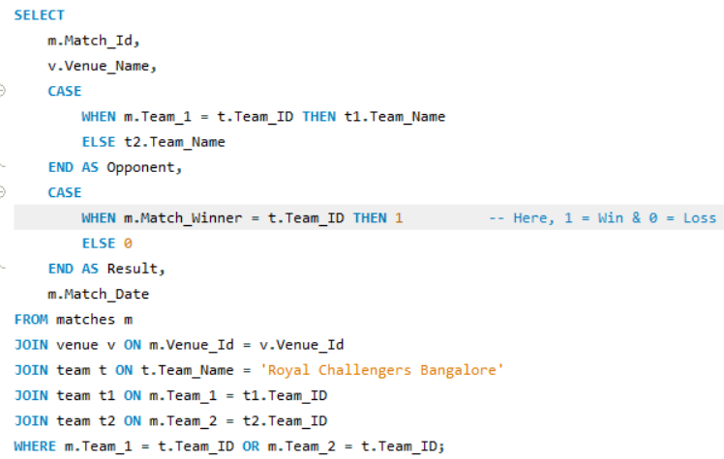

**Insights-  
  
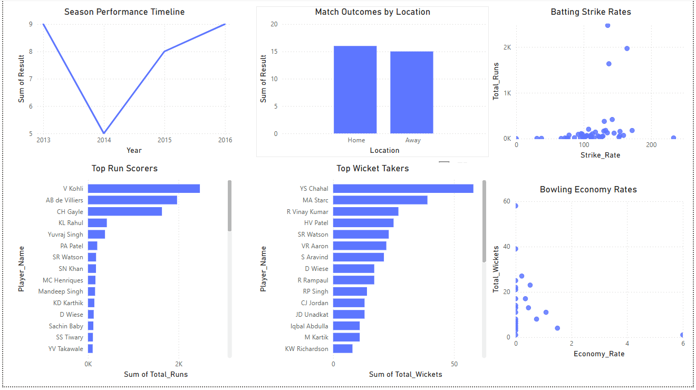** 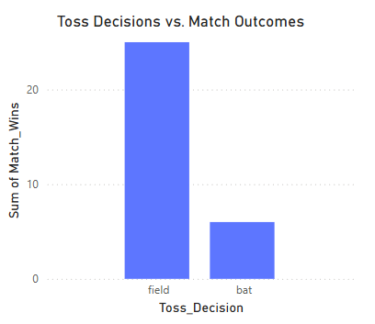

1. **Season Performance**

* + The team had a low point in 2014 but showed strong improvement in 2015 and 2016, finishing on a high note.

1. **Home vs Away Performance**
   * Match outcomes are fairly balanced between home and away games, showing that the team performs well in different conditions.
2. **Top Batsmen**
   * **Virat Kohli, AB de Villiers, and Chris Gayle** are the highest run scorers, forming a strong and reliable batting lineup.
3. **Top Bowlers**
   * **Yuzvendra Chahal, Mitchell Starc, and Shane Watson** are the most effective bowlers, contributing significantly with wickets.
4. **Batting Strike Rates**
   * Most players with consistent run totals strike between **100–150**, indicating a controlled yet impactful approach.
   * A few players have very high strike rates but low total runs, likely used in finishing roles.
5. **Bowling Economy Rates**
   * Several bowlers have good economy rates along with decent wicket counts, which is key for maintaining pressure in matches.

**Conclusion-**

1. The team was strongest in 2016, both in performance and team composition.

2. A balanced mix of batting power and bowling variety exists.

3. Consistency across venues shows mental toughness and adaptability.

**Recommendations-**1. **Retain the core players** (Kohli, de Villiers, Chahal) who consistently contribute.

2. **Identify and back all-rounders** like Shane Watson who add value in both departments.

3. **Support high-strike-rate players** for finishing roles in the batting order.

4. **Strengthen the middle-order** to avoid over-reliance on top batsmen.

5. Continue leveraging players with **low economy and high wicket-taking ability** to control games.

**An analytical breakdown of why RCB has not won a trophy is as follows:**  
  
1. Weak bowling lineup.   
2. Unstable finishers.

3. Difficulty achieving success on home ground.

4. Over-reliance on key players.

5. Inconsistent team performance.

6. Lack of a well-balanced team.

7. Insufficient reliance on high-performing Indian batsmen.

8. Struggles under pressure in knockout games: unable to perform in high-stakes situations.

1. How would you approach this problem if the objective and subjective questions weren't given?

Ans:   
1. **Evaluate last year's team performance** to identify strengths and areas for improvement.

2. **Consider top performers in domestic cricket**, as they could offer great value during the auction.

3. **Analyse key performance metrics** to make informed player selections.

4. **Give special attention to death-over bowlers**, as they play a crucial role in closing matches.

5. **Include a reliable all-rounder** to add balance and flexibility to the squad.

6. **Target players who have a strong record against RCB** to gain a strategic advantage.

7. **Retain consistent and high-impact performers** who have delivered results for the team.

8. **Avoid overspending on underperforming players**, ensuring better value for money.

9. **Strengthen the middle order and finishing options** to ensure stability and strong match closures.

10. **Look for a powerplay specialist bowler** who can provide early breakthroughs.

1. In the "Match" table, some entries in the "Opponent_Team" column are incorrectly spelled as "Delhi_Capitals" instead of "Delhi_Daredevils". Write an SQL query to replace all occurrences of "Delhi_Capitals" with "Delhi_Daredevils".

Ans: **Aim:** In this case, the question refers to the table "Match" and the column "Opponent_Team," where changes need to be made. However, the available data does not include this information. Therefore, I am assuming that this data would exist and have written a query accordingly.

To replace all occurrences of "Delhi_Capitals" with "Delhi_Daredevils," the query would be as follows:  
  
**Query-**  
